
SHABBIR ANASWALA
Data Analyst with 6 years of experience in interpreting and analysing data for driving business solutions. Proficient knowledge in statistics, Mathematics and analytics. Excellent understanding of business operations and analytical tools for effective analyses of data.

CONTACT
PROFESSIONAL EXPERIENCE

FIGmd, Inc.

 DATA MINING FOR CMS REGISTRIES {Data Mining Analyst, Nov2018- Present}
- Using Google App script Created DQC (Data Quality Check) Tool for Data Exploration. Tool can interact with Big Query and gets processed data as per user input.
- Automated Creating, Managing, Deleting, assigning Nodes to Google DataProc Clusters For Exploring data as per CMS guidelines
- Interconnecte Postgre, SQL an SQL server data using python
- Using PySpark processed huge data from Google DataProc Clusters and created visualization for same in Data Studio.
- Developed Python Selenium for extracting data from EMR and EHR
- Extracted Service Locations, Ids and etc from XML and HTML files using Python Web scrapping
- Developed a Utility in Python to access AWS Bucket Data (Using BOTO 3 Client) to find number of times particular Keyword appearing in different Text sections.
- Created KNN algorithm for predicting performance of Provider.
- For text data created sentiment Analysis which helped team in segregating "Positive, Negative and Neutral " text
- Developed Tableau Dashboard for different sections of Practices and interlinked them. Connected Data Source with Big Query
- Created multiple Dashboards for Practice and Provider Level Performance using Google Studio
- Developed Automation report in Python during MIPS submission for different Registries
TATA CONSULTANCY SERVICES

 Metadata Ingestion with 5/3rd Bank {Senior Data Analyst, July 2018- Nov2018}
- To create data and business lineages on banking application using IBM IGC tool and to perform data mining using Global ID tool.
- Setting up data base connections, data refreshment and performing certain validations using SQL Queries in IGC tool.
- POC for building logistic regression for credit card data provided by 5/3rd bank using Python and MS Excel.
 LIFE SCIENCE PROJECT ON AMGEN (HELLE) {Data Analyst, Sept 2016- June 2018}
- To prepare and check the data in reports are properly exported using SAS Base 9 and Excel
- Build a process improvement macro name as “Parser Time Saver” for internal use of project people.
- Developed a Logistic Regression Model Using SAS for a data provided by Amgen for a Patient Disease.
 GLOBAL INTRADITC CITI BANK {Test and Data Analyst, Dec 2013-Aug2016}
- To track name of fraud transaction and report them to check before releasing their transaction.
- Created Macro for performing above activity which had compensated 4 days work to 2 hour

Shabbiranaswala@gmail.com
9437683409 or 9051959545
Shabbir3311
Nanded City, Pune, Maharashtra India (411041)






✓

SKILLS
- Statistical Analysis
- Data Exploration
- Data Visualisation
- Model Building
- Dashboard Creation

Python R
SAS APP Script
BIG Query Data Studio
Google Cloud Platform

CERTIFICATION




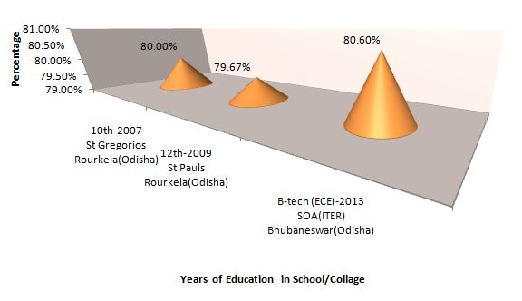
ACHIEVEMENTS
INTEREST
Freelancing



Star Performer Award
On- Spot Award

Star Team Award
Old Music
Google Spreadsheet
Interviews
Video Editing
Badminton
◻ Academics

